Capstone 3 Project Idea: Build a system that ingests social media data, analyzes sentiment and trends, and forecasts future engagement/trends over time.
Dataset: luminati-io/Social-media-dataset-samples: A collection of multiple social media dataset samples. Each sample contains over 1,000 records. These datasets are ideal for brand awareness, consumer sentiment analysis, and for tracking social media presence
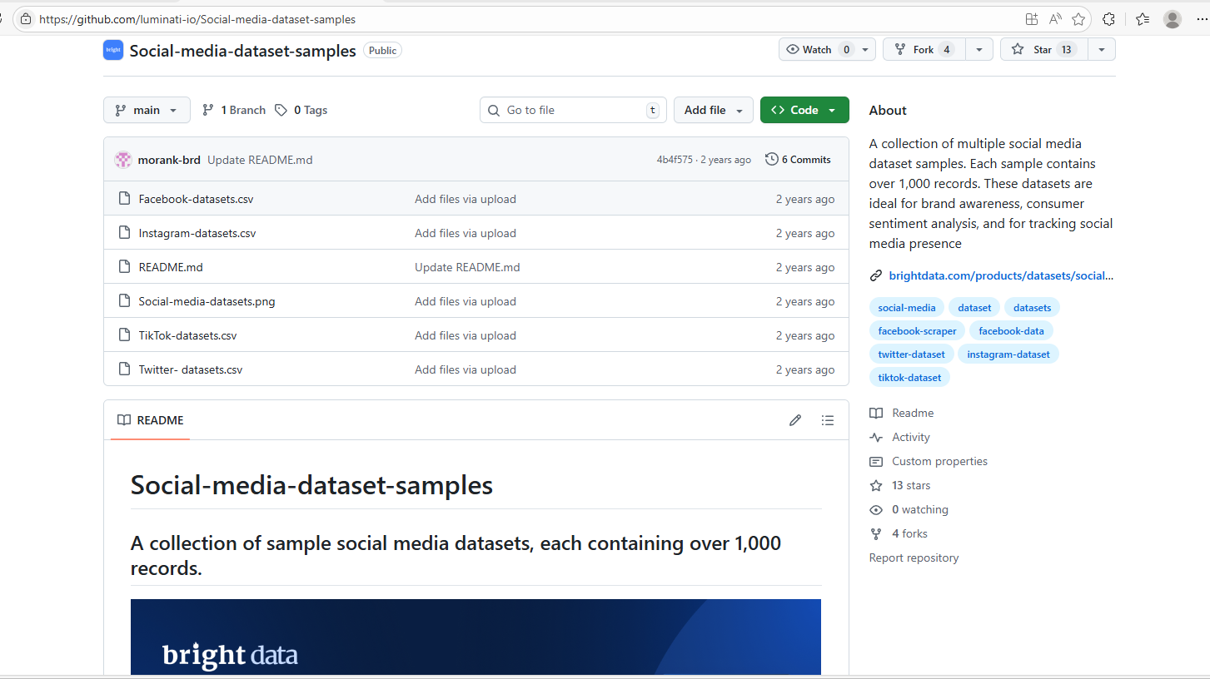

Pipeline stages to work on:
- Ingest & standardize
  - Parse date formats, convert to timezone-aware datetime.
  - Normalize platform-specific fields to unified names.
- Data cleaning & wrangling
  - Handle missing values, DQ checks, deduplicate posts.
  - Clean text (encoding, HTML tags, emojis, URLs).
- EDA
  - Understand distributions, correlations, temporal patterns.
- Feature engineering
  - Text features (sentiment, embeddings).
  - Time features (lags, rolling stats).
  - Aggregations by hashtag, platform, time granularity.
- NLP modeling
  - Sentiment classification and/or topic modeling.
- Time-series modeling
  - Forecast engagement, sentiment trends, or hashtag popularity.

